SCOTTISH AMERICAN MILITARY SOCIETY
SOCIETY NOBLE IN THE NOBLESSE OF SCOTLAND

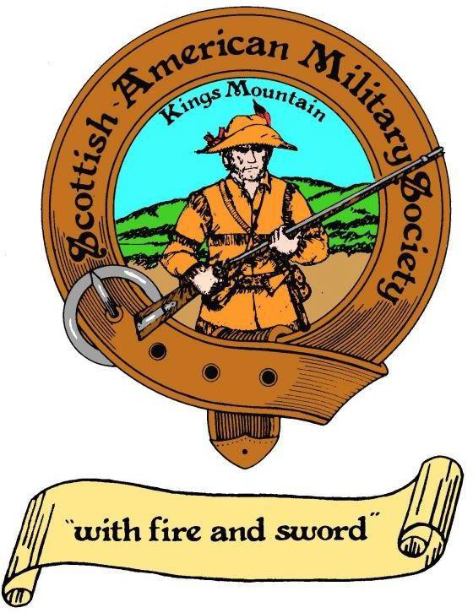

SAMS MEDAL AND CERTIFICATE
LETTER OF INSTRUCTION
EFFECTIVE January 31, 2024

KENNETH A. LLOYD
COMMANDER, SCOTTISH AMERICAN MILITARY SOCIETY

- PURPOSE: The purpose of this Letter of Instruction (herein known as LOI) is to set consistent rules, requirements, and expectations for requesting and awarding of the SAMS Medal and Certificate to the Junior Reserve Officer Training Corps (herein known as JROTC) and the Reserve Officer Training Corps (herein known as ROTC). There are some exceptions as noted at the end of this document.

Specific instructions regarding the wear and display of the medal are at the discretion of the Armed Service to which the recipient is associated with and applicable uniform and awards directives.

The primary expectation of presentation is in person, by a member of a Post in appropriate SAMS uniform as indicated in the current SAMS Dress Code. The Color Guard uniform is preferred for all presenters. There may be a time where the presentation is more formal and Prince Charlie attire with small medals is appropriate.

- UNIQUE CONCERNS: The SAMS medal and certificate are not currently considered an established award for the Armed Forces JROTC or ROTC. We are in the process of correcting that deficiency. Many JROTC and ROTC units are familiar with our award/certificate and have a reasonable amount of latitude in which to have the medal awarded/presented and worn by their members. This LOI will be amended as needed upon receiving service recognition. One goal of this award is for the SAMS Medal to carryover from secondary education (JROTC) to collegiate (ROTC), if approved by the various Armed Services.

- EXPECTATIONS: The SAMS medal and certificate should always be presented in person wherein travel is reasonable. Presentation, in any other fashion, should be managed at the discretion of the Post, Regional and National Commander. The presenter should always be in uniform, preferably the color guard version. A picture should be taken to commemorate the occasion and details of the recipient, the recipient’s unit, locale, the presenter, the date of the presentation and any other pertinent comments provided for inclusion in a future issue of the Patriot Magazine.

Only one medal and certificate is to be presented to a school/unit each year. The only exception to this expectation is if the school has multiple ROTC units (not found in a high school setting) such as The Virginia Military Institute, The Citadel, etc. having other services represented, then the post is allowed to present enough medals per year so each separate Armed Service ROTC receives recognition. Awards at the collegiate level will also include a challenge coin. See awards matrix. Questions should be directed to the National Awards Chair.

This picture and presentation information should be sent to the National Public Relations Officer and the National Awards Chair (natlawardscmtechair@s-a-m-s.org) within a reasonable time (96 hours). They will assist in getting the picture and information included in The Patriot magazine. Pictures containing incorrect uniform wear will not be included.

- QUALIFICATIONS: Any member of the JROTC or ROTC recipient unit can be awarded the SAMS Medal and Certificate. There are several awards individuals can receive in their academic and military pursuits and SAMS endeavors to make our medal qualifications unique. There is sufficient flexibility in that Post Commanders and the receiving unit instructors can reasonably adjust requirements as needed.

It is preferred that the medal and certificate be awarded to an individual either in the sophomore or junior academic term. The same academic level is suggested for ROTC units. The rationale is it can be used as a means of motivation for the recipient, as well as future recipients. Most awards routinely presented tend to be for graduating individuals and serve as end of tour awards. The SAMS medal and certificate are not specifically tied to academic performance or military acumen. They are not tied to a person achieving a certain rank or ranking within their units. It should be used to highlight the unique characteristics of the “Over the Mountain Men”. The SAMS medal and certificate are unique. It is possible the same individual could receive the award twice (in subsequent years), that would be the recipient unit’s responsibility. There is no plan currently for a person receiving multiple awards; e. g. stars/oak leaf clusters for a second award.

The medal and certificate can be presented to any qualified member of the receiving unit, exclusive of the SAMS unique membership requirements. Specifically, they can be of any gender or genealogical heritage. They are not required to have stated any future enlistment objectives to qualify for the award. There are no specific citizenship requirements. There are no essay requirements per the SAMS organization; however, this does not preclude the receiving unit from levying this expectation. The recipient should be in the top 20% of their class year in military excellence.

Characteristics of “Over the Mountain Men” are; not quick to anger, resolute, patriotic, having moral courage, perseverance in the face of adversity, unwilling to give up regardless of obstacles, etc.

- PROCESS: There are several different ways a unit can request an award and presentation. There is a brochure attached to this LOI the unit can used to provide the post’s contact information. There is a medal request attachment indicating the minimum information needed. Email, text and telephonic means can be used as alternatives to the brochure as appropriate. Posts can also reach out to various units and offer an award and presentation, if they are familiar with a unit and/or the unit did not realize it was available to them. The latter option may be the most effective until such time as the SAMS medal is added to various Armed Service directives. Attendance and displays at Highland games are also a way to get this information out.

Once contact is made, the request process begins. The requesting unit should allow at least four weeks from the presentation date for notification and preparation. It is the Posts responsibility to maintain sufficient medals and coins (as applicable). Certificates with embossed seals can be requested from the National Awards Chair for presentation if the Post does not have a printing capability. Each Post should have an award committee chair/director or adjutant to handle these requests depending on their area. Large metropolitan areas should consider a separate person from the adjutant. The requesting unit should provide the following details (see attachment):
  - Full name of the recipient
  - Cadet Rank
  - Academic Term (Sophomore or Junior)
  - Unit Name
  - Unit Point of Contact (name, rank, direct phone, email, address, etc.)
  - Date and Time of Presentation
  - Location of Presentation
  - Any Special Information/Requirements (uniforms, meals, etc.)
The presentation can be done by any member of the unit who is qualified to also serve in the Post Color Guard, unless otherwise expressly approved by the Post, Regional and/or National Commander. The award should not be presented by an auxiliary member unless that is the only option available.

- TRACKING of AWARDS: Each post should keep a simple spreadsheet for each school year indicating the basic details of their awards to include the following:
  - Date of the Award
  - Recipient’s Full Name and Rank
  - Unit/School
  - JROTC or ROTC
  - City/State
  - Unit Senior Instructor/School Principal
  - Was picture taken and submitted to National PRO and National Awards Chair (National PRO will not include in Patriot Magazine if uniform is not correct, be squared away)

Units can keep additional details in their spreadsheets as necessary, but these minimum details need to be tracked for the purpose of annual reporting to the National Awards Chair. The email address is located on a previous LOI page or in the Patriot Magazine. Post spreadsheets should be sent directly to the National Awards Chair at the end of each school year or no later than June 30. Carbon copies should be provided to the Regional Commanders.

- EXPENSES: All expenses are currently incurred by each Post until further notice or direction. Medals and challenge coins can be ordered through the National Quartermaster. Embossed, self-adhesive seals can be obtained through the National Awards Chair. Certificates can be requested from the National Awards Chair. The certificate paper with pre-printed scalloped border is from national office supply stores. Certificate frames can be obtained at discount stores; e. g. Dollar General by each post. Frames will not be mailed by the National Awards Chair or stocked by the National Quartermaster. Medal boxes and coin boxes will be shipped with the medals when ordered from the National Quartermaster. Please direct specific questions to the National Awards Chair.

- Exceptions to the LOI: These exceptions apply primarily to the following types of groups, but are not all inclusive and can be subject to modification; Sea Cadets, Civil Air Patrol, Young Marines, Scouts BSA, etc. Those posts who have a relationship with the previously mentioned groups are permitted to award the SAMS Medal, provide certificates and/or challenge coins per the matrix providing they do so in a manner consistent with the intent of this LOI. Pictures for inclusion in The Patriot should be managed as indicated in paragraph 3 of this LOI. Wearing the SAMS Medal will be up to the leaders of the receiving group; e. g. Sea Cadets, Civil Air Patrol and Young Marines. Scouting groups will only be given a Challenge Coin to be accompanied by the certificate. See Awards Matrix.

Attachments:
- Certificate example
- List of award components
- Example of information brochure for SAMS Medal Trifold
- SAMS Medal and Certificate Application
- SAMS Award Matrix
- Abbreviated Medal and Certificate Presentation Comments
- Example of Medal Tracking Spreadsheet

Certificate Example:

This is an example, an exact format with updated verbiage will be forwarded to each post if necessary. The embossed seal can be the seal used by your post or the one provided with by the National Assistant Adjutant or National Awards Chair.

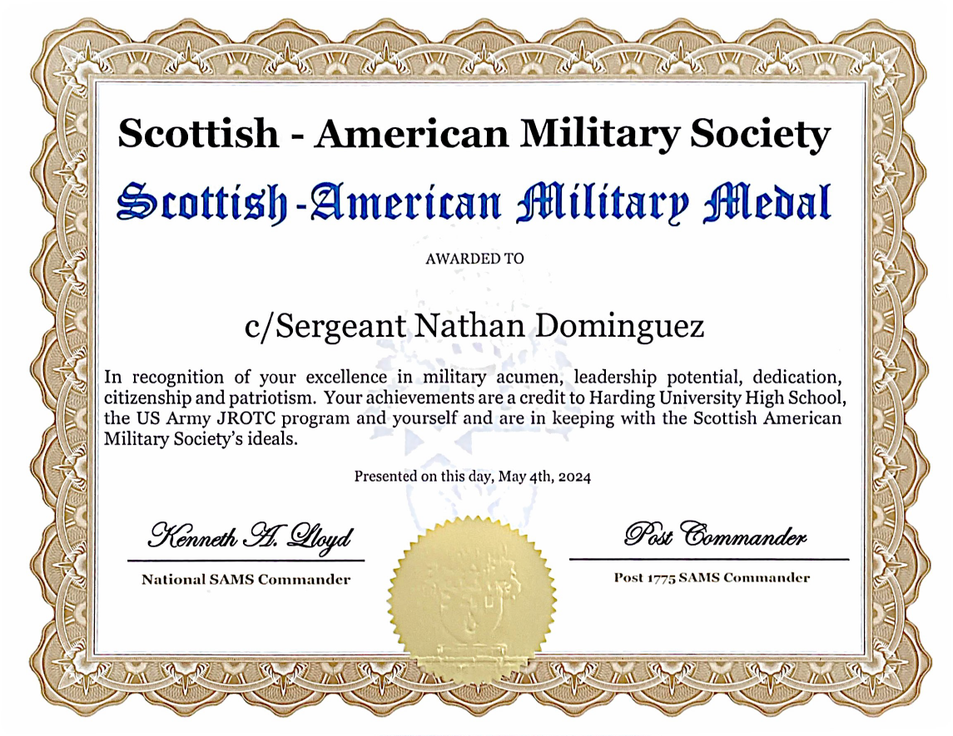

There should only be two signatures on the certificate; the National Commander and the Post Commander. (The Post number will be changed to match each post.) The exception would be if the same person filled both positions. The font used for the signatures should be Bolded Edwardian Script ITC size 28. The remaining font is Georgia and Old English.
The SAMS crest is a washed out watermark in color. If not washed out, it overrides the verbiage when printed.
The self-adhesive gold seal can be the Post corporate seal or the SAMS crest held by the National Awards Chair (preferred).

List of Award Components:
- SAMS Medal with Ribbon (From National QM)
- SAMS Challenge Coin (From National QM)
- Small jewelry box (U-line S-7279 White Swirl with cotton batting, from National QM or directly from Uline)
- Small ring box (Uline S-10600 White Swirl with foam insert, from National QM or directly from Uline)
- Certificate (Staples brand Geographics Premium Certificates)
- Self-Adhesive Embossed Seal (Staples if using post embosser, National Awards Chair if requesting SAMS logo, the SAMS logo is preferred)
- Black Picture frame (basic $2 or less frame, post locally sourced)

SAMS Medal with Ribbon

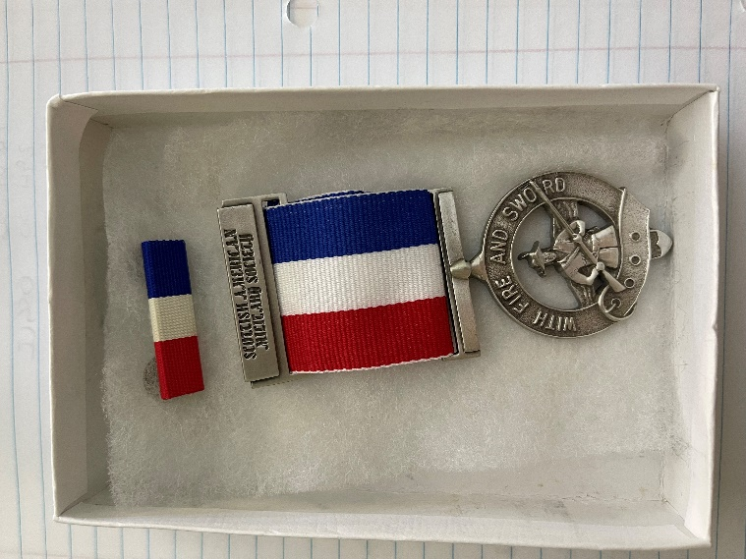

SAMS Challenge Coin

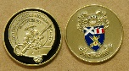

Example of SAMS Medal Information Trifold Brochure:

Front

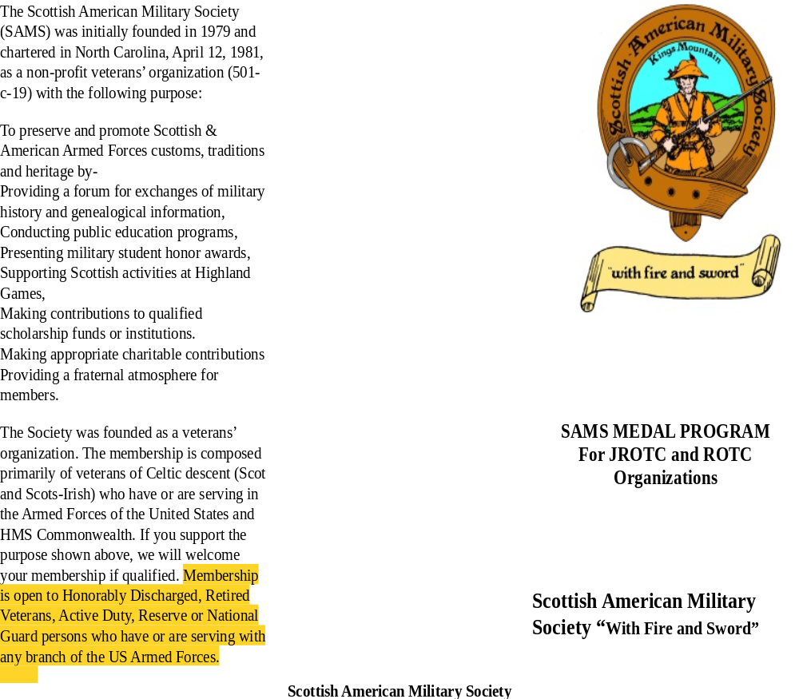

Back

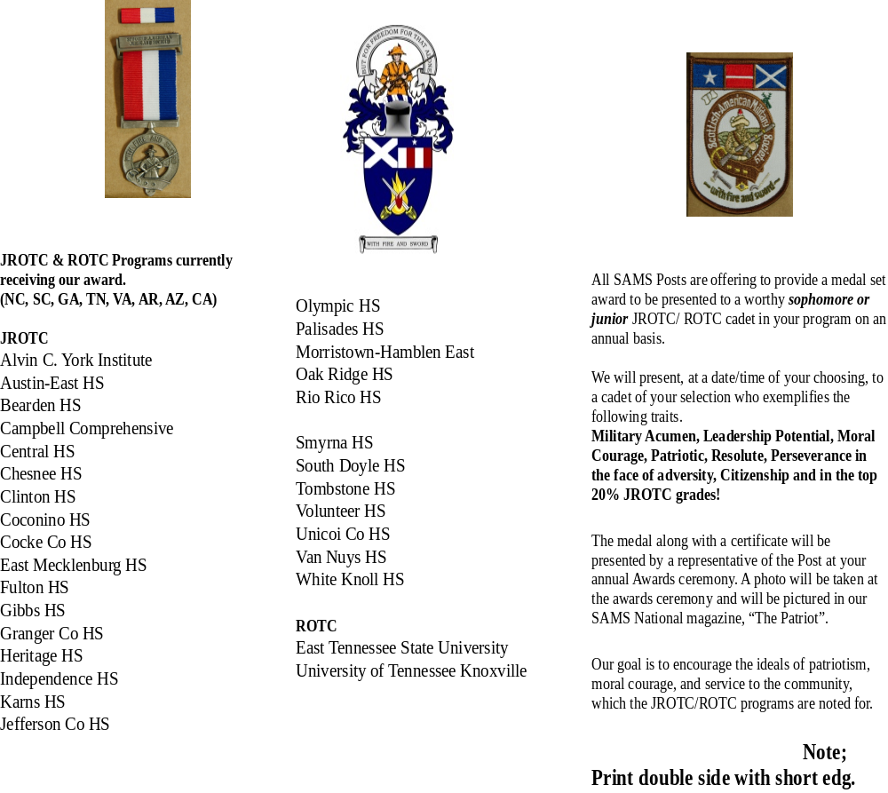

SAMS Medal and Certificate Application Format

This application can be sent to the respective post or region or the information can be sent to the post or region via email. Email addresses are available via S-A-M-S.org under Contact Us. Communication should be simple, but complete.

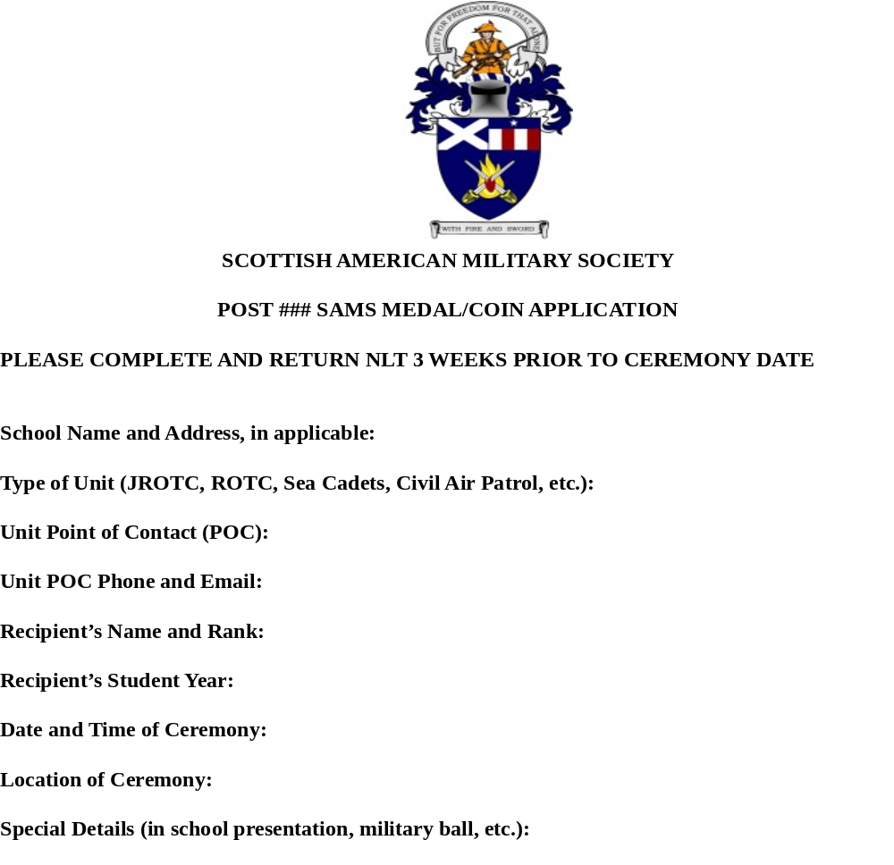

SAMS Award Matrix

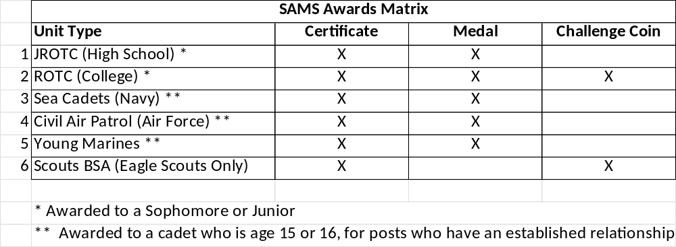

There is history of a SAMS dirk. It has been decided this will become an internal award and no longer given to ROTC cadets, mainly due the cost and time to produce. The current cost of an engraved dirk is approximately $150. See the National Operations Officer for questions or instructions regarding the SAMS dirk.

Abbreviated Medal and Certificate Presentation Comments

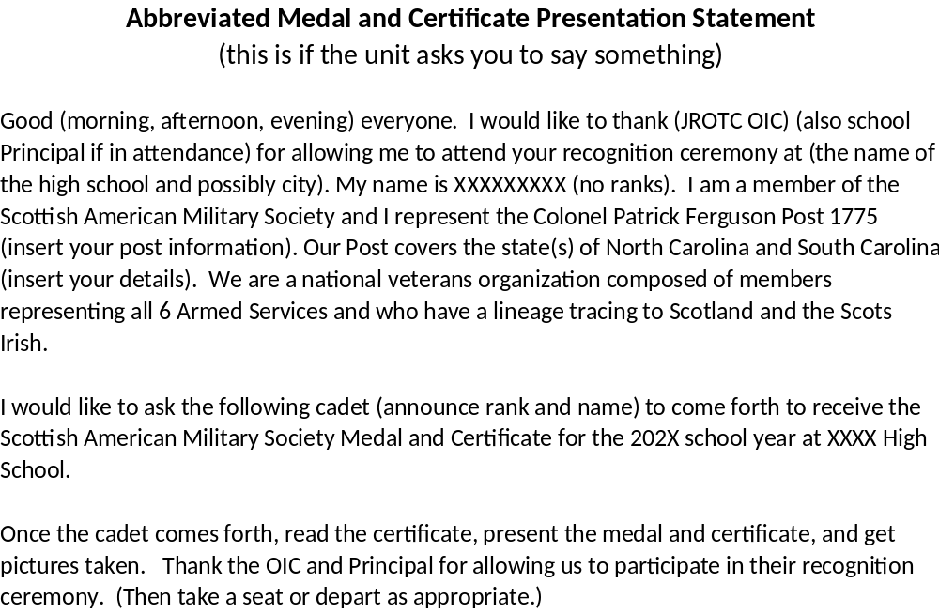

Example of Medal/Coin Tracking Sheet

